George Cabel Kirby, Sr
- Memorial
- Photos
- Flowers
- Edit
- Share
Learn about removing the ads from this memorial...
Birth: Sep. 21, 1879 Halifax Halifax County Virginia, USA  Death: Sep. 27, 1962 Roxboro Person County North Carolina, USA  Son of Benjamin Kirby and Caroline Carter  Family links:  Spouse:  Ola McSherry Kirby (1894 - 1967)  Burial:  Person Memorial Cemetery  Roxboro  Person County  North Carolina, USA  Edit Virtual Cemetery info [?]  Created by: RTerry  Record added: Apr 19, 2010  Find A Grave Memorial# 51336407 | 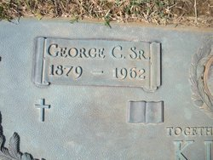  Added by: RTerry  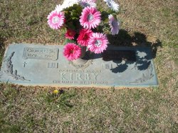  Added by: RTerry

